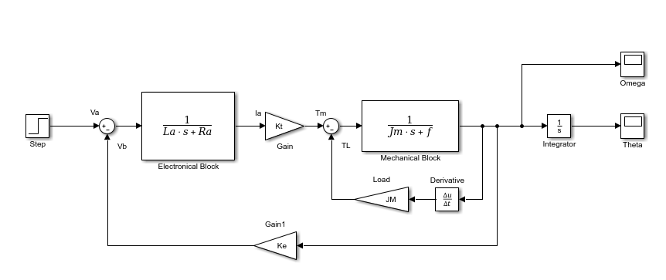

Figure 1 Block Diagram without any assumption

Transfer function simplification **with** load:

$$T\left(s\right)=\frac{\frac{1}{J_{m}s+f}}{1+\frac{J_{M}s}{J_{m}s+f}} → \frac{1}{\left(J_{m}+J_{M}\right)s+f} → \frac{K_{t}}{\left[\left(J_{m}+J_{M}\right)s+f\right]\left[L_{a}s+R_{a}\right]} →$$

$$\frac{K_{t}}{\left(J_{m}L_{a}+J_{M}L_{a}\right)s^{2}+\left(L_{a}f+J_{m}R_{a}+J_{M}R_{a}\right)s+R_{a}f+K_{t}K_{e}} (velocity)$$

$$\frac{K_{t}}{\left(J_{m}L_{a}+J_{M}L_{a}\right)s^{3}+\left(L_{a}f+J_{m}R_{a}+J_{M}R_{a}\right)s^{2}+\left(R_{a}f+K_{t}K_{e}\right)s } (position)$$

The load JM can be substituted by loads J­1 or J2.

Transfer function simplification **without** load:

$$T\left(s\right)=\frac{K_{t}}{J_{m}s+f} → \frac{K_{t}}{(J_{m}s+f)(L_{a}s+R_{a})} → \frac{K_{t}}{J_{m}R_{a}s^{2}+\left(J_{m}R_{a}+L_{a}f\right)s+R_{a}f} →$$

$$\frac{\frac{K_{t}}{J_{m}R_{a}s^{2}+\left(J_{m}R_{a}+L_{a}f\right)s+R_{a}f}}{1+\frac{K_{t}K_{e}}{J_{m}R_{a}s^{2}+\left(J_{m}R_{a}+L_{a}f\right)s+R_{a}f}} → \frac{K_{t}}{J_{m}L_{a}s^{2}+\left(J_{m}R_{a}+L_{a}f\right)s+R_{a}f+K_{t}K_{e}} (velocity)$$

$$\frac{K_{t}}{J_{m}L_{a}s^{3}+\left(J_{m}R_{a}+L_{a}f\right)s^{2}+\left(R_{a}f+K_{t}K_{e}\right)s} (position)$$

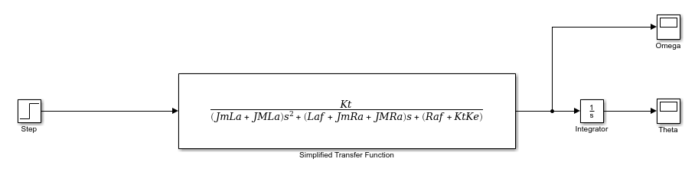

Figure 2 Simplified Transfer Function with Load

For this project, we will be using the GM9236S013 Motor. The motor constants required to solve the equations and be able to plot the step responses and the bode plots are:

* Torque Constant, Kt 0.0229 Nm/A
* Back-EMF Constant, Ke 0.0229 V/rad/s
* Resistance, Ra 0.71 Ω
* Inductance, L 0.66 mH
* Rotor Inertia, Jm­ 0.0000071 kg.m2
* Damping Constant, f 0.00085 N.m.s

1. For the open loop transfer function:

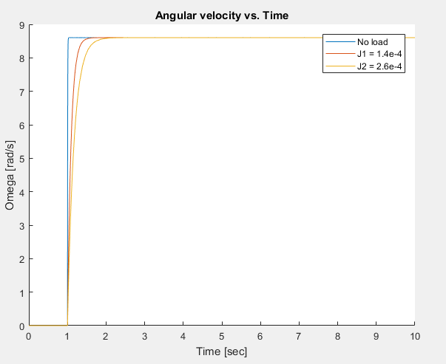**Step response:**

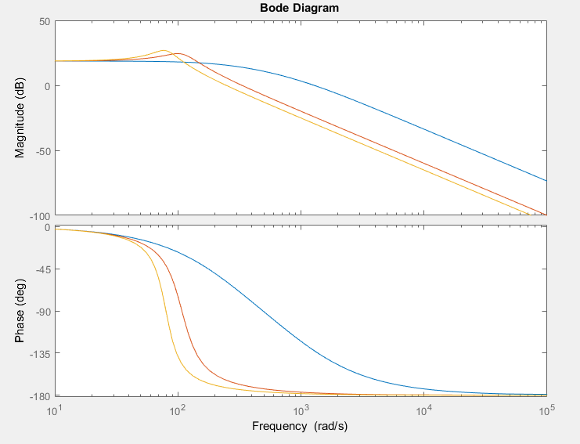**Bode plot:**

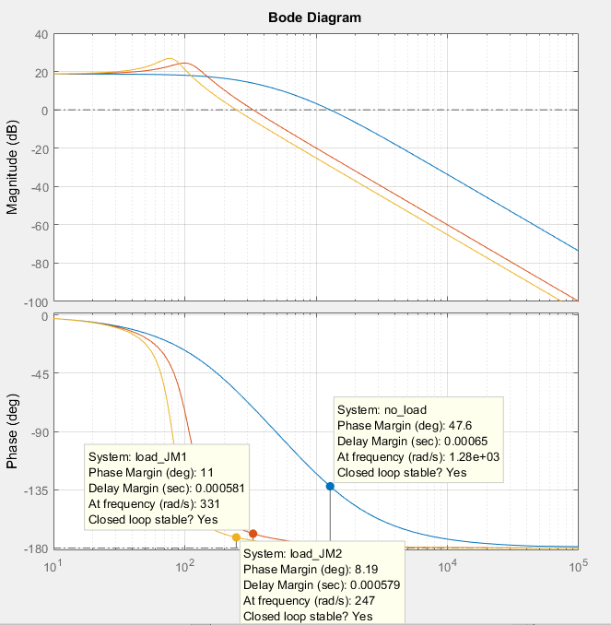Information about Gain Margin, Phase Margin, and stability can be seen in the following figure:

For the closed loop transfer function:

**Step response:**

m-code used:

hold on

JM = 0; sim('MECH473Simp'); plot(t,omega); xlabel('Time [sec]'); ylabel('Omega [rad]'); title('Angular position vs time');

JM = 0.00014; sim('MECH473Simp'); plot(t,omega);

JM = 0.00026; sim('MECH473Simp'); plot(t,omega); legend('No load','J1 = 1.4e-4','J2 = 2.6e-4');

hold off

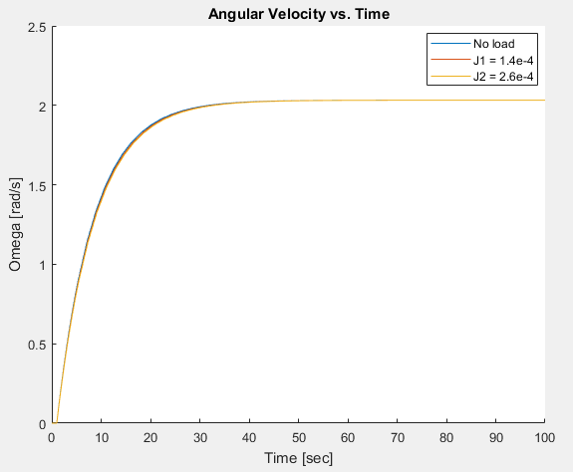

**Bode plot:**

m-code used:

Ka = 2.5;

Gear_red = 1/5.9;

num = 0.0229*Ka*Gear_red;

JM0 = 0;

JM1 = 0.00014;

JM2 = 0.00026;

den0 = [0.000004686+0.00066*JM0 0.035500561+5*JM0 0.00477441];

den1 = [0.000004686+0.00066*JM1 0.035500561+5*JM1 0.00477441];

den2 = [0.000004686+0.00066*JM2 0.035500561+5*JM2 0.00477441];

no_load = tf(num,den0);

load_JM1 = tf(num,den1);

load_JM2 = tf(num,den2);

bode(no_load,load_JM1,load_JM2)

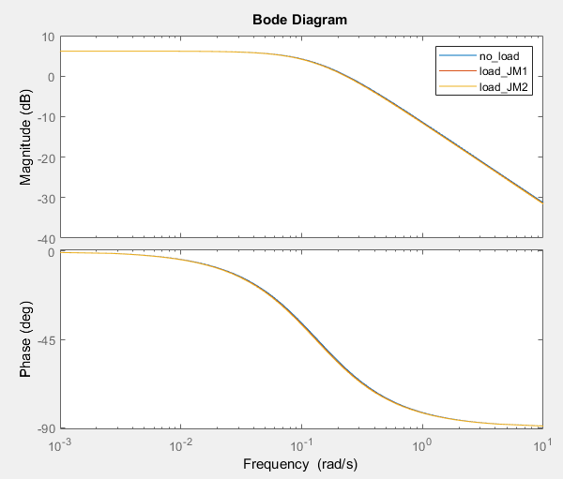

Information about Gain Margin, Phase Margin, and stability can be seen in the following figure:

